Participanti ANTEBELLUM 2011
Masini istorice clasice
10 iulie 2011

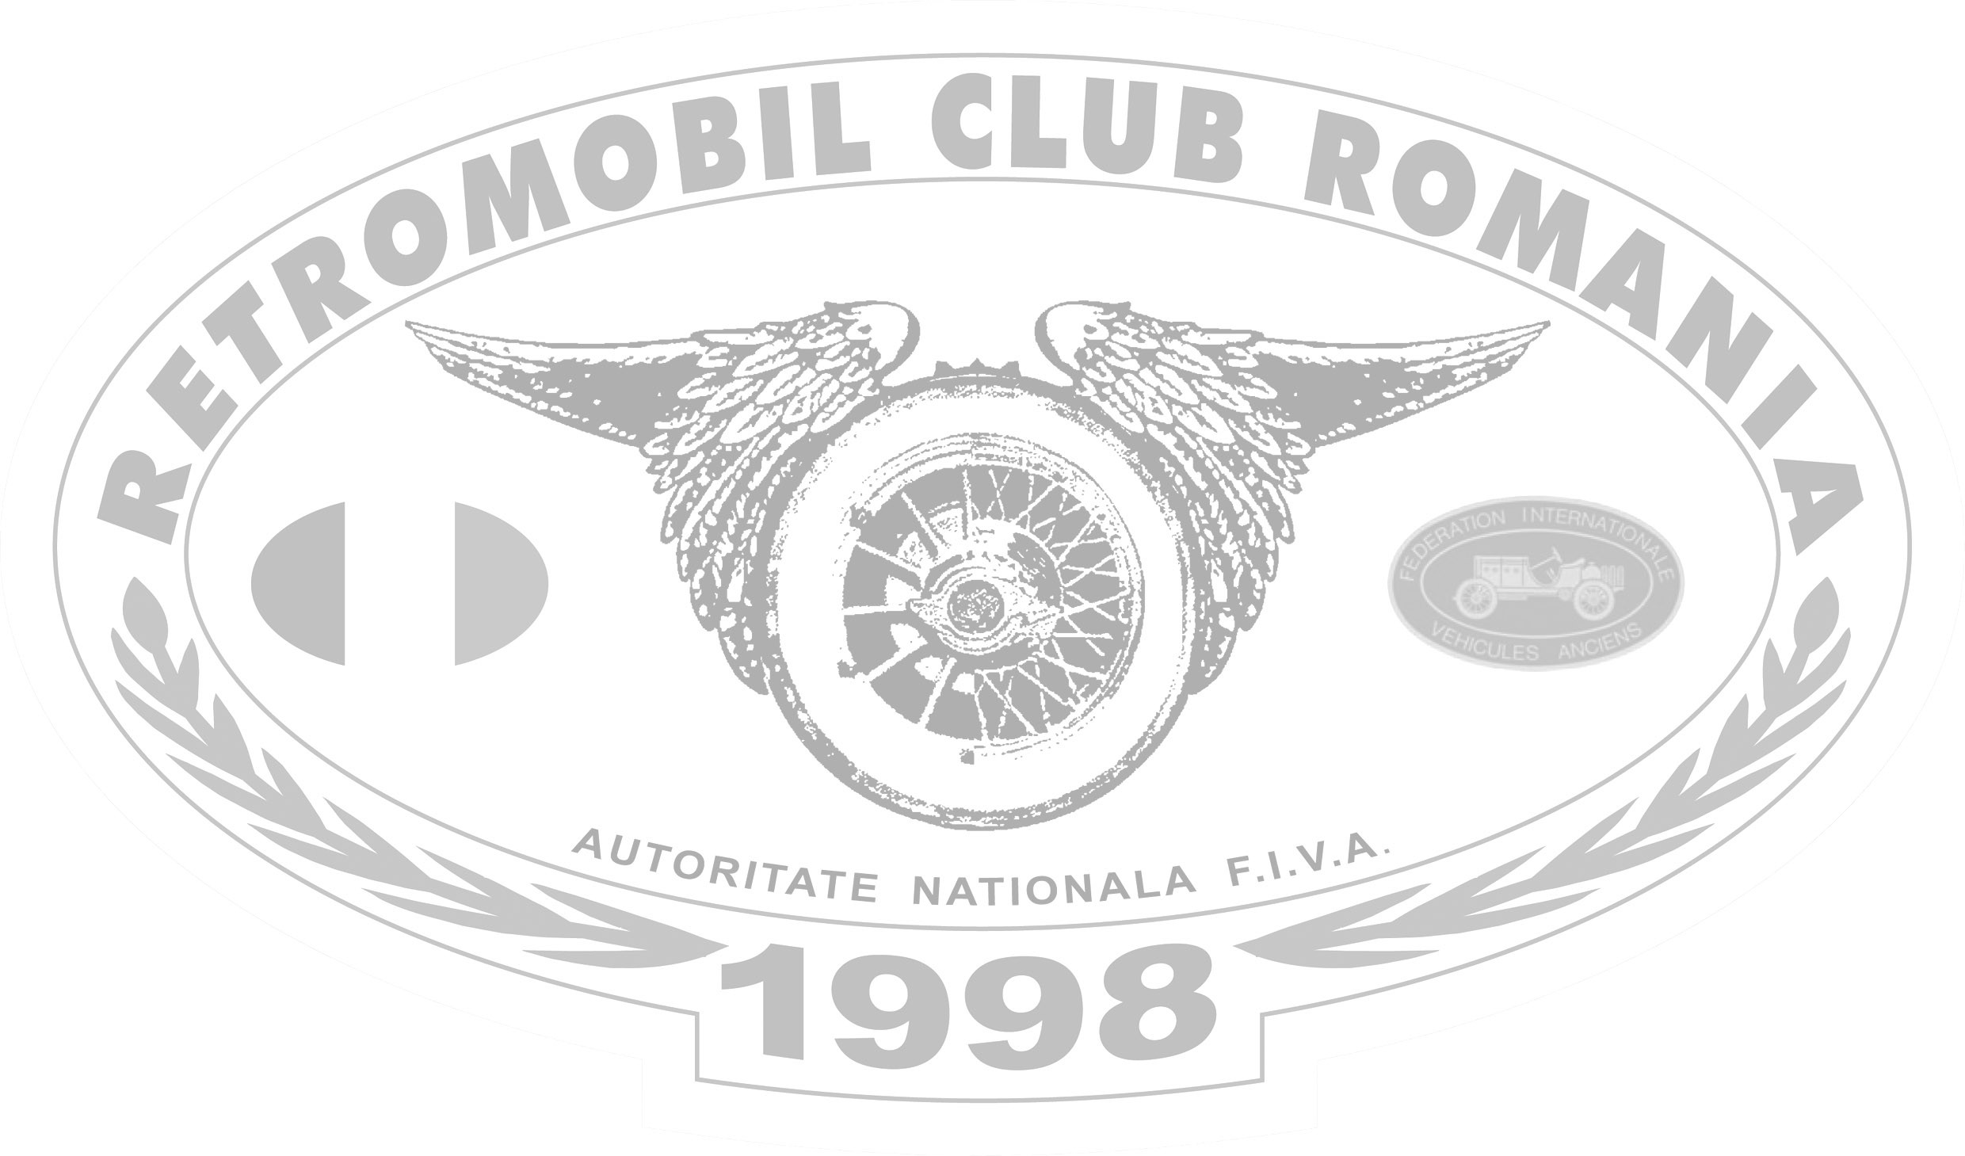

Nr. crt. | Participant | Vehicul istoric | An de fab. | Nr. Inmt.
1 | Florian Marin | Chevrolet Impala | 1960 | B 77 LXA
2 | Dan Constantin Voicu | Opel Rekord P2 | 1961 | B 610 PEL
3 | Giuseppe Rossi | Fiat 1100 D | 1964 | B 64 VCS
4 | Cristian Dumitru | Renault Dauphine (neatestat) | 1967 | B 27 GUI
5 | George Pantelimon | M 461 | 1968 | B 461 ARO
6 | Mihai Dumitru – invitat | Volga M 21 | 1968 | B 68 VLG
7 | Bogdan Burcea | ARO M 461 | 1970 | B 01 ARO
8 | Alexandru Mihalcea | Fiat 850 Sport Coupe | 1970 | B 45 GBC
9 | Mircea Ionescu | Porsche 911 Targa | 1972 | B 999 FUN
10 | Attila Torok– invitat | Ford Mustang | 1972 | B 972 MUS
11 | Emil Tanase | ARO M 461 | 1974 | B 29 TOA
12 | Lucian Minea | Mercedes Benz 220 D | 1974 | IF 01 LWU
13 | Dan Bonciog | Porsche 914 | 1975 | B 38 ALO
14 | Ioan Baboi | ARO M 461 | 1975 | B 95 ARO
15 | Ion Picu | ARO M 461 | 1975 | B 84 PYC
16 | George Tanase | Opel Kadet | 1977 | B 83 GEO
17 | Cristian Gaspar – invitat | Mercedes Benz 350 SE | 1979 | B 979 DRG
18 | George Nica | Oldsmobile Cutlass Supreme | 1979 | B 09 NKG

