Participanti ANTEBELLUM 2011
Masini istorice antebelice
10 iulie 2011

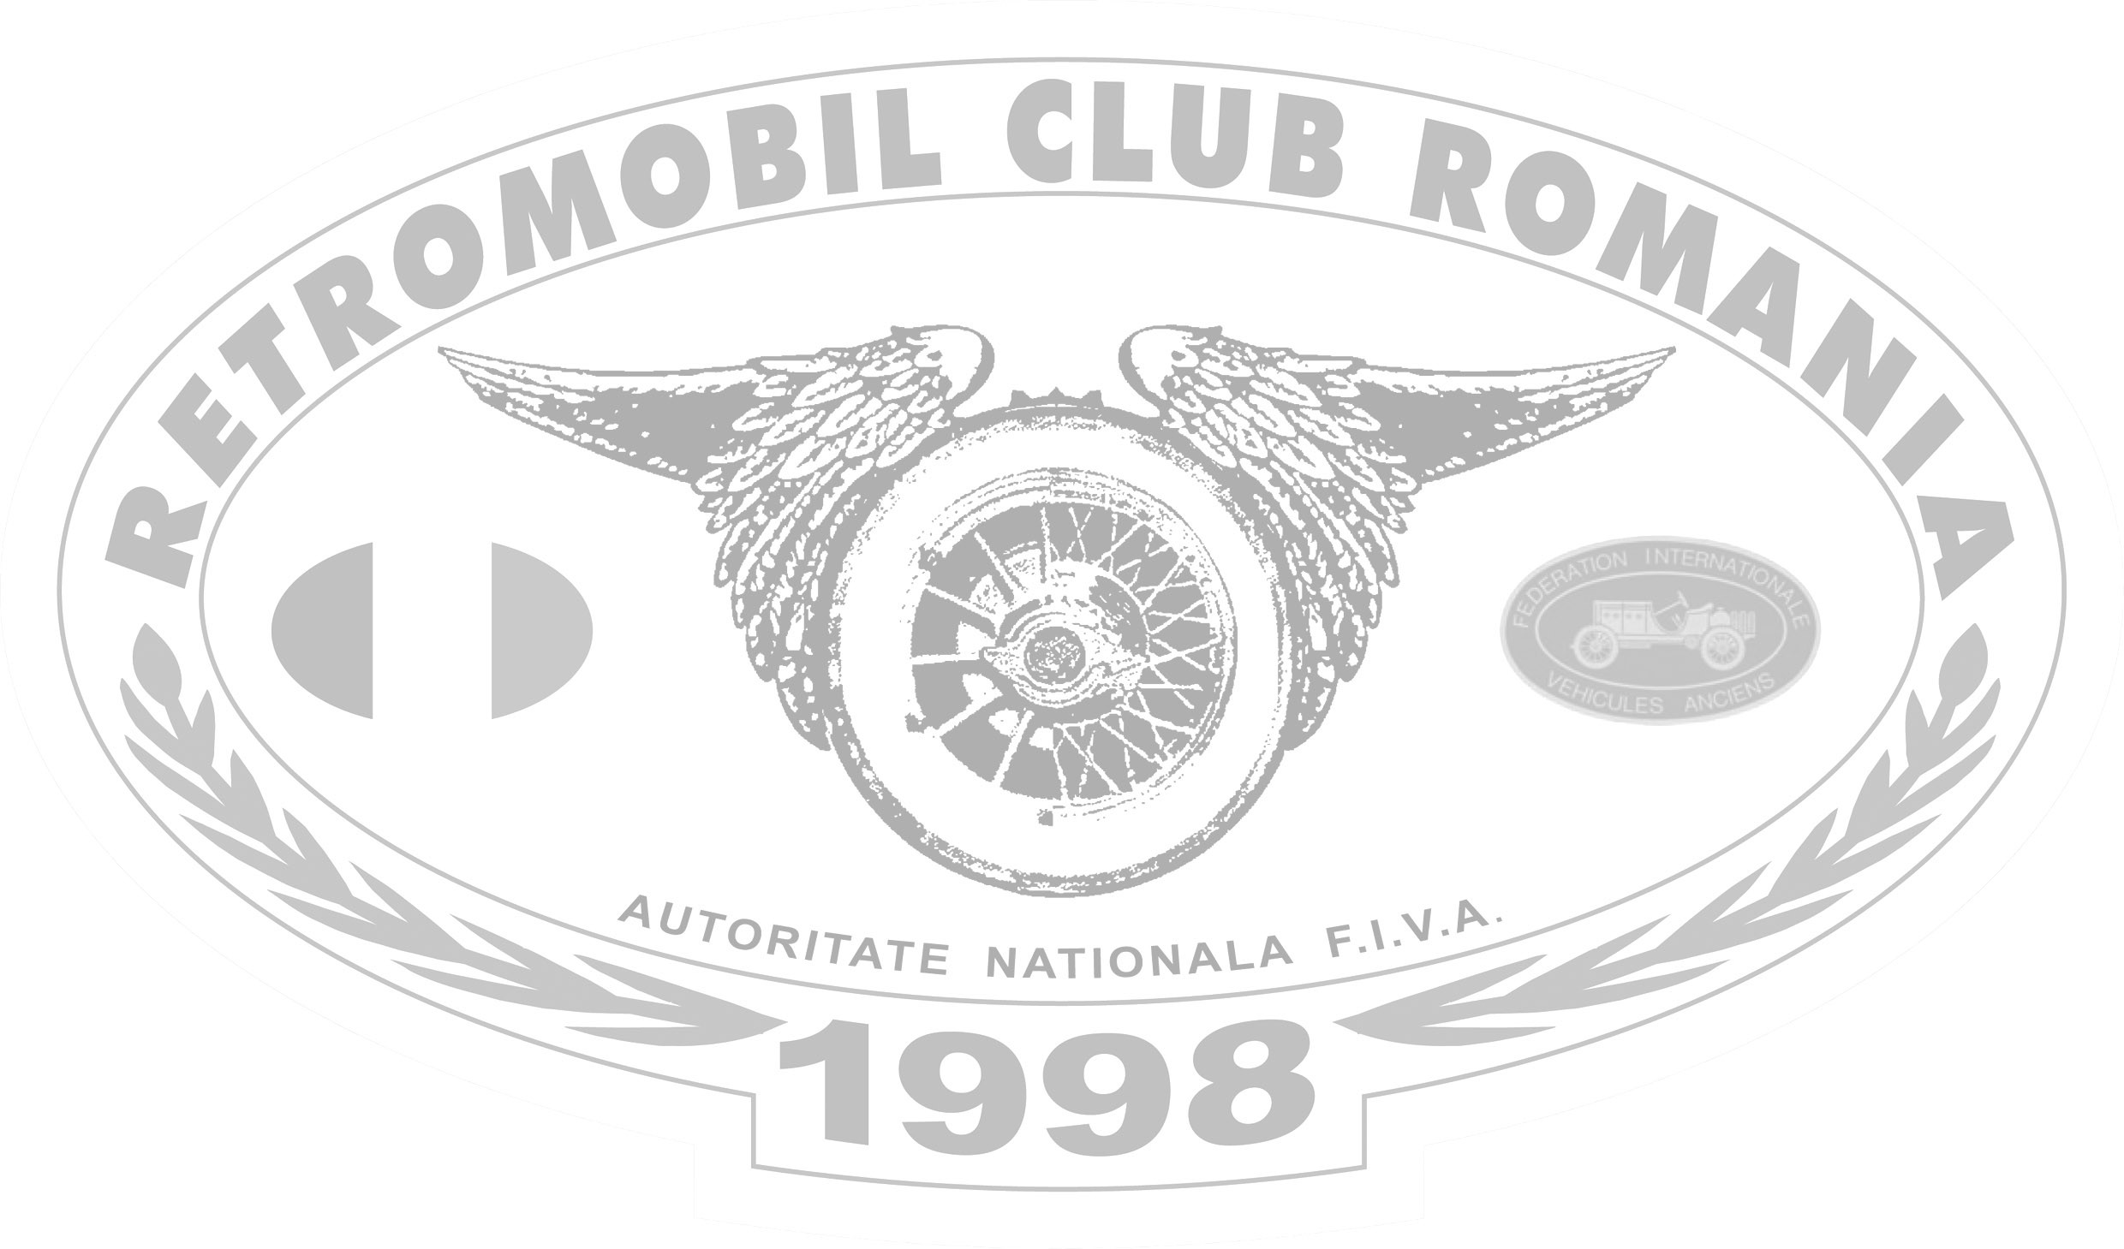

Nr. crt. | Participant | Vehicul istoric | An de fabricatie | Nr. Inmt.
1 | Mihai Lazar | Ford Model T | 1923 | B 923 EPC
2 | Adrian Dumitru | Ford Model A Roadster | 1928 | B 17B GB
3 | Paula Perlea - invitat | Ford Model A Phaeton | 1928 | B 72 EPC
4 | Rocco Nuzzi | Mercedes 200 C | 1936 | B 33 DBZ
5 | Mircea Ganea | Hanomag 15 K | 1936 | B 36 HAG
6 | Constantin Minca | Wanderer W52 | 1937 | B 63 TXH
7 | Bogdan Coconoiu | Aero 30 Roadster | 1937 | B 38 AER
8 | Viorel Burcea | Opel Super Six | 1938 | B 380 PEL
9 | Dan Cazacu | Skoda 1100 OHV | 1938 | B 38 SKD
10 | Mihai Mezincescu | Fiat 500 | 1938 | PH 08 LXC
11 | Lucian Dobre | Mercedes 170 V | 1938 | B 97 LYZ
12 | Paul Pascu (Stage Expert) | Citroen Traction | 1939 | B 35 RET
13 | Razvan Badulescu | Fiat 1100 | 1939 | B 24 WJG
14 | Dan Miulescu | Skoda 1100 OHV | 1939 | B 29 VYX
15 | Ovidiu Ciobanu | VW Typ 82 (neatestat) | 1940 | /
16 | Calin Balanescu | Fiat 500 | 1942 | B 42 TPO
17 | Catalin Balasa | Willys CJ 2A | 1947 * | B 66 JEP
18 | Radu Manu | Willys CJ 3A | 1948 * | B 48 JEP

* Model lansat inainte de 31.12.1945

